**Static Routing Topology**

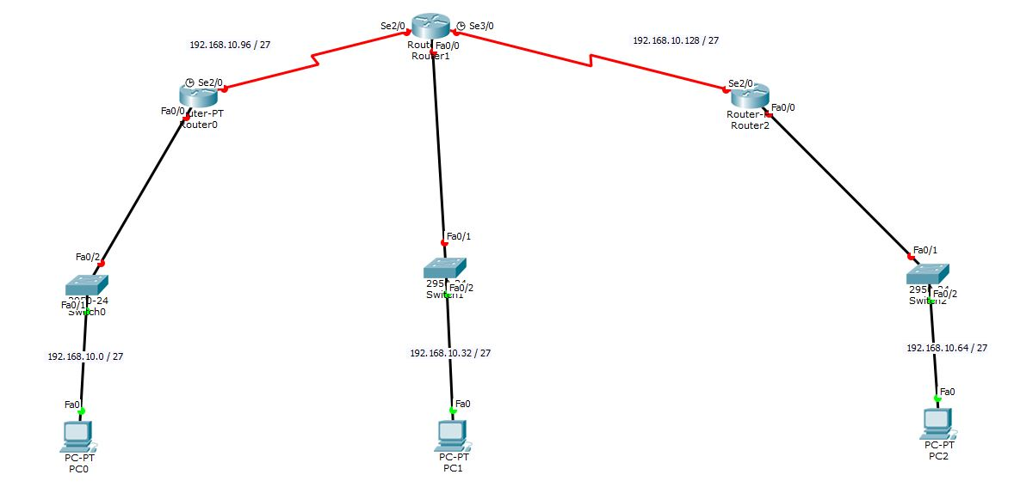

**Task 01: Addressing Table**

|  |  |  |  |
| --- | --- | --- | --- |
| **Device** | **Interface** | **IP address** | **Subnet Mask** |
| **ROUTER 0** | **Fa0/0** | **192.168.10.1** | **255.255.255.224** |
| **Se2/0** | **192.168.10.97** | **255.255.255.224** |
| **ROUTER 1** | **Fa0/0** | **192.168.10.33** | **255.255.255.224** |
| **Se2/0** | **192.168.10.98** | **255.255.255.224** |
|  | **Se3/0** | **192.168.10.129** | **255.255.255.224** |
| **ROUTER**  **2** | **Fa0/0** | **192.168.10.65** | **255.255.255.224** |
| **Se2/0** | **192.168.10.130** | **255.255.255.224** |
| **PC0** |  |  |  |
| **PC1** |  |  |  |
| **PC2** |  |  |  |

**Task 2: Subnet Information**

|  |  |  |  |  |
| --- | --- | --- | --- | --- |
| **Subnet Number** | **Subnet Address** | **First Host Address** | **Last Host Address** | **Gateway Address** |
| **1** |  |  |  |  |
| **2** |  |  |  |  |
| **3** |  |  |  |  |
| **4** |  |  |  |  |
| **5** |  |  |  |  |

**Task 3: Static Routing Table for Router0**

|  |  |  |
| --- | --- | --- |
| **Network Address** | **Mask Address** | **Next Hop** |
|  |  |  |
|  |  |  |
|  |  |  |

**Task 3: Static Routing Table for Router1**

|  |  |  |
| --- | --- | --- |
| **Network Address** | **Mask Address** | **Next Hop** |
|  |  |  |
|  |  |  |

**Task 3: Static Routing Table for Router2**

|  |  |  |
| --- | --- | --- |
| **Network Address** | **Mask Address** | **Next Hop** |
|  |  |  |
|  |  |  |
|  |  |  |